Login to https://famelive.signin.aws.amazon.com/console

Username: admin
Password: Admin123

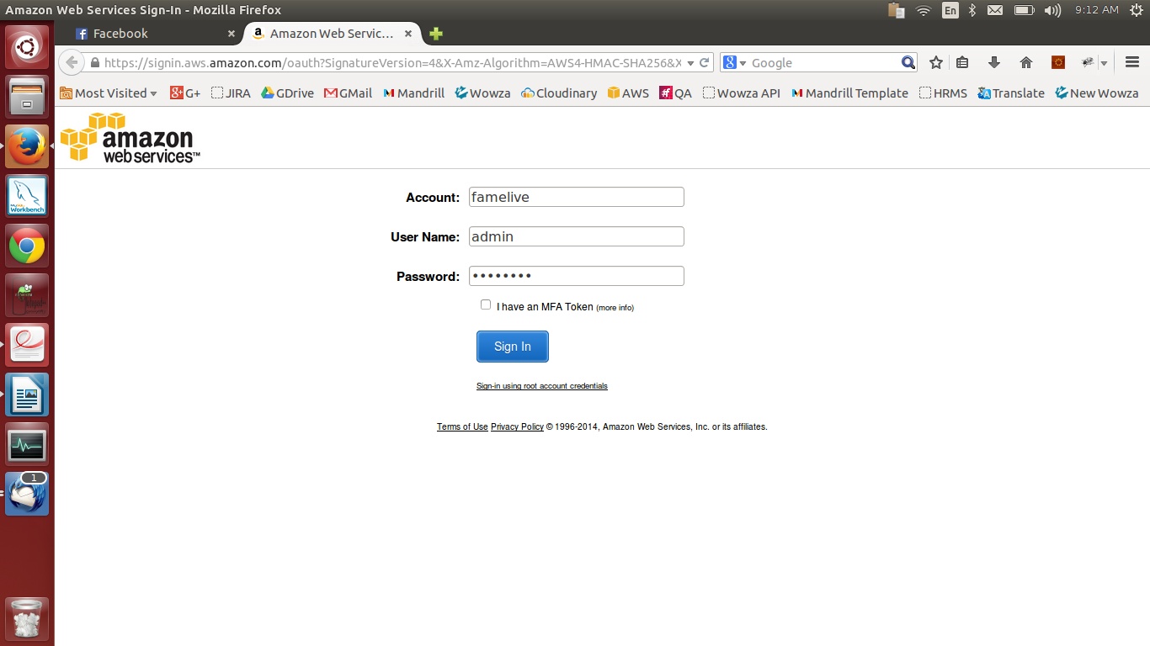

Click on EC2 link

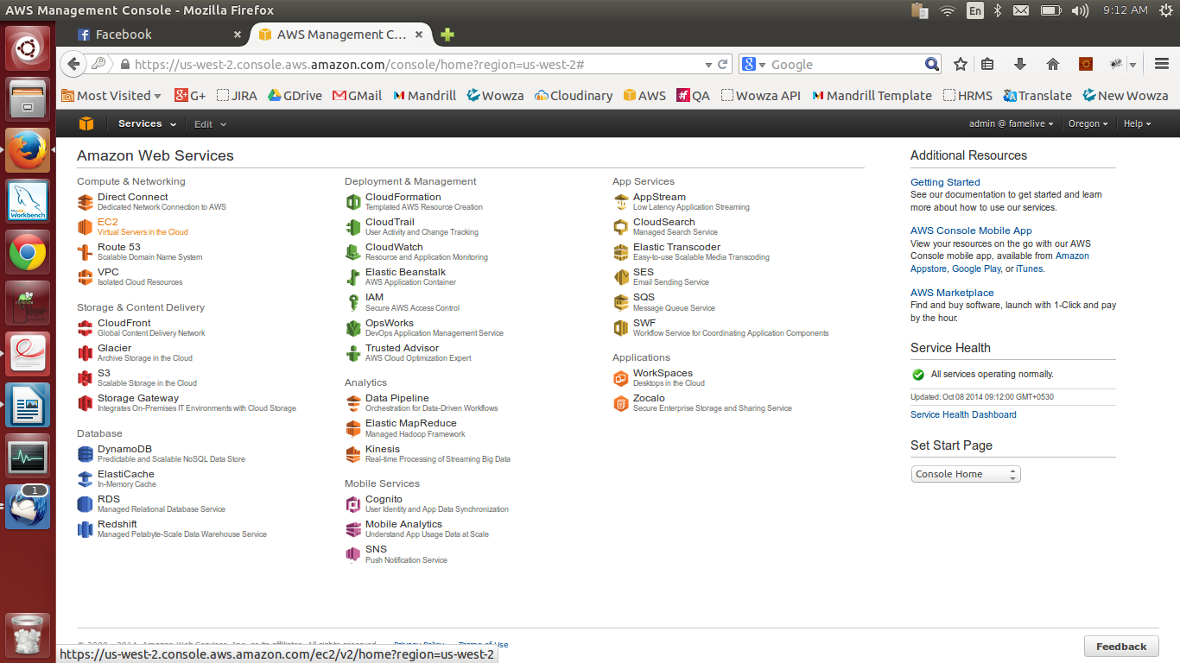

Click on running instances link under resources panel

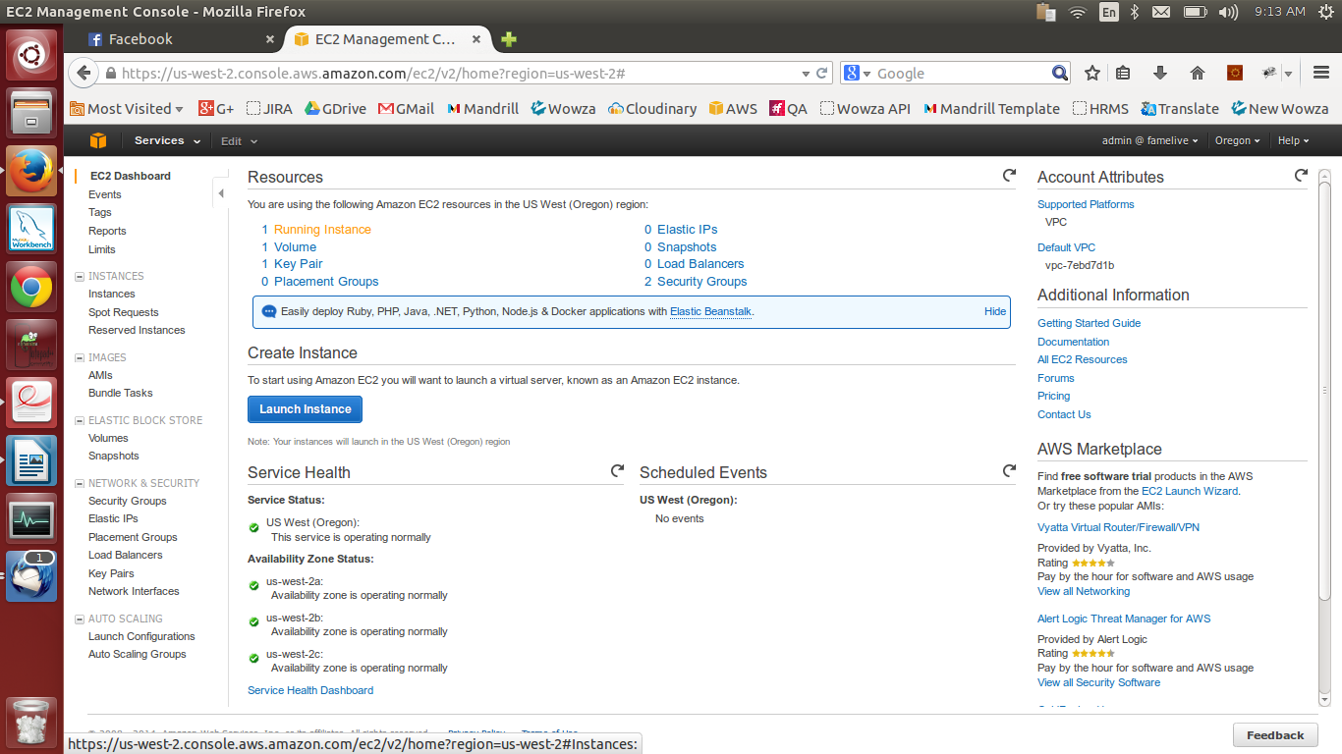

Select checkbox of new instance

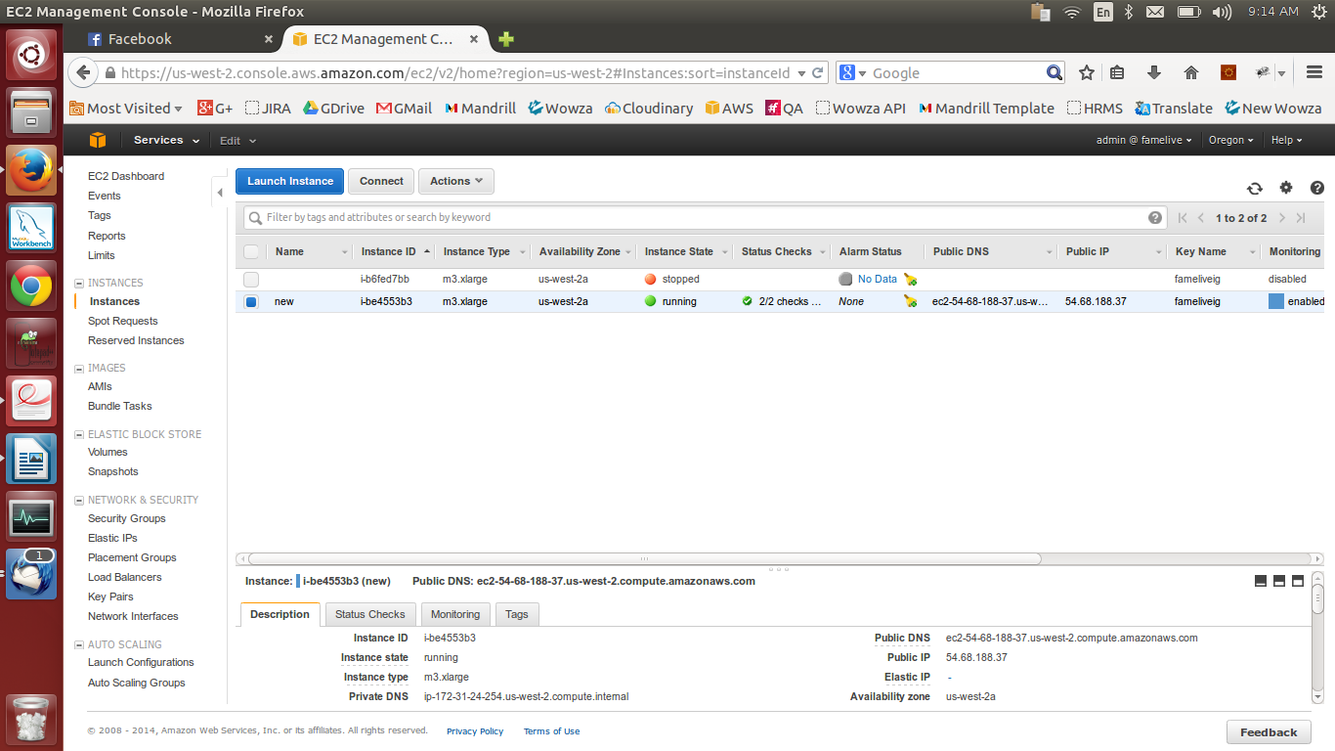

Click on Action button

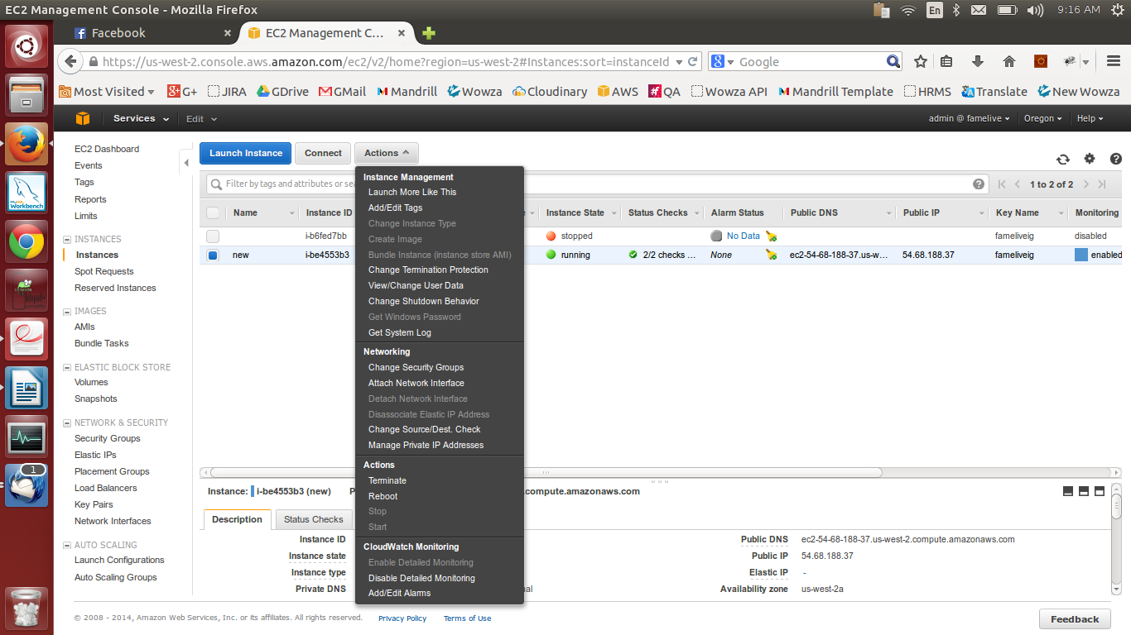

Now select and click on desired action under Actions sub-menu

Note: Never select terminate option. It will delete the EC2 instance.

